

| **Group Name** : Group 5 – C2108G1 + C2109I | |
| --- | --- |
| **Group members:** | Ngo Minh Chien  Le Anh Lan  Truong Anh Long  Cao Duy Quang  Le Dang Truong Phat |
| **Topic:** | Coffee shop manager |
| **Instructor** | To Hoang Anh |

**Table of Contents**

**Chapter 1. The Prologue** 2

**1.1.** **Introduction to the problem** 2

**1.2.** **Topic goal** 2

**Chapter 2. Contents** 2

**2.1.** **System Requirements** 2

**2.1.1.** **System functions** 2

**2.1.2.** **Objects using the system** 3

**2.2.** **System design** 4

**2.2.1.** **Use Case Diagram** 4

**2.2.2.** **Entity Relationship Diagram** 5

**2.2.3.** **Database specification** 5

**2.2.4.** **Database Diagram** 10

**2.2.5.** **Site map** 11

**2.2.6.** **Some algorithms applied in the project** 12

**2.3.** **Some illustrations** 14

**2.4.** **Tasksheet** 17

Research phase of the topic 17

Requirements analysis stage 17

Stage design 17

Development stage 17

Testing phase 18

**2.5.** **Validate cheklist** 18

**Chapter 3. Conclusion and development direction** 18

**3.1.** **Conclusion** 18

**3.2.** **Development** 18

# **Chapter 1. The Prologue**

* 1. **Introduction to the problem**
* Coffee management software is a software that helps managers to know information such as: customer order, payment amount, total number of orders sold, employee's name, detailed list management books and status of drinks, dishes…
* Currently, there are many coffee shop management software, depending on different purposes, business owners will choose the right coffee management software for them. For an entrepreneur, management software is very important.
* Especially, the coffee management is very complicated and has many related problems. Especially when the restaurant is crowded, the staff can't remember all and remember exactly what the customer ordered, enter the ingredients when they are in excess or in shortage... making the revenue drop. Since then, the requirement to manage coffee software is a very necessary and extremely important job.
* Management features make it easy and convenient for managers to manage anytime, anywhere: once you have an account on a certain coffee management software with simple operations on your smartphone, you can You can know how your cafe is operating, how many customers, how many orders, the name of the cashier who is working, the amount of ingredients to decide whether to import more goods or not. , selling price and cost price are updated at the same time… Management software allows you to not need to go directly to the shop and still be able to monitor all activities anytime, anywhere through a very detailed display system.
* Employee management is easier and more professional: when each transaction is made, it is displayed with the employee's name. From there, the shop owner can recognize and evaluate the work efficiency or promptly have reminders for employees.
* On each coffee management software, there is a very detailed and complete display of all the tasks of the day and longer. When a problem occurs, you just need to check the system to know what the cause is.
  1. **Topic goal**
* Development of software to manage coffee shops.
* Research JavaFX development technology.
* Research to optimize the sales management process.
* Report and summarize results.

# **Chapter 2. Contents**

1. **System Requirements**
   * 1. **System functions**

* The application will have two logins: employee login and login manager.
* Employees are only allowed to perform tasks in the employee window and cannot view other important program information.
* Import and export bills: Bill information will be stored in the database.
* Enter bill of materials: Information will be saved in the database.
* Access to personal account information.
* Management window:
* Employee management: View, add, delete, update employee information, manage working time.
* Inventory management: Inventory of consumption and purchases of resources -> money spent.
* Order management: Inventory of income through orders -> receipts.
* Revenue management: Summary of revenues and expenditures.
* The design database accurately and clearly reflects the real world, enabling the software to exploit and provide access and editing rights from the users who act on the data.
* Managers will create their own accounts and from there create lower-level accounts for employees.
* Each: Employee, Manager, Orders, Invoices, Menu Items, Ingredients, etc. all have a unique ID.
  + 1. **Objects using the system**
* **Staff:**
* Login, view, add, delete, edit account information.
* View descriptions of products and ingredients.
* Search for products by need (Product name, product type).
* Create an order.
* Delete, view, modify information of current orders.
* Payment of orders.
* Enter bill of materials into warehouse.
* Log out.
* **Manage:**
* Login, view, add, delete, edit account information.
* View, add, delete, edit employee information.
* View, add, delete, edit material inventory information.
* View, add, delete, edit product information (dishes, drinks).
* View, add, delete, edit order information (By day, month, year).
* Revenue statistics (By day, month, year).
* Log out.
  1. **System design**
     1. **Use Case Diagram**

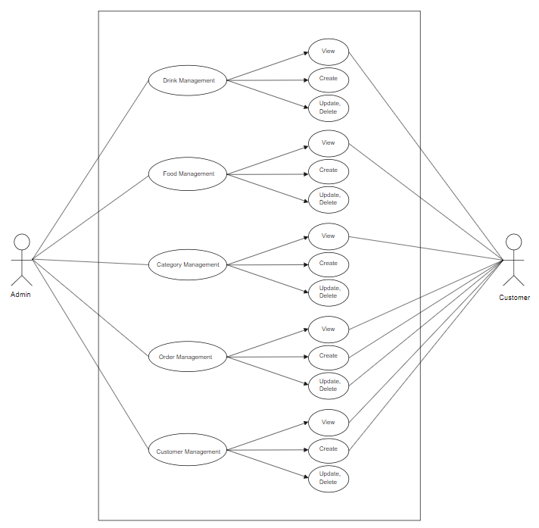

* + 1. **Entity Relationship Diagram**

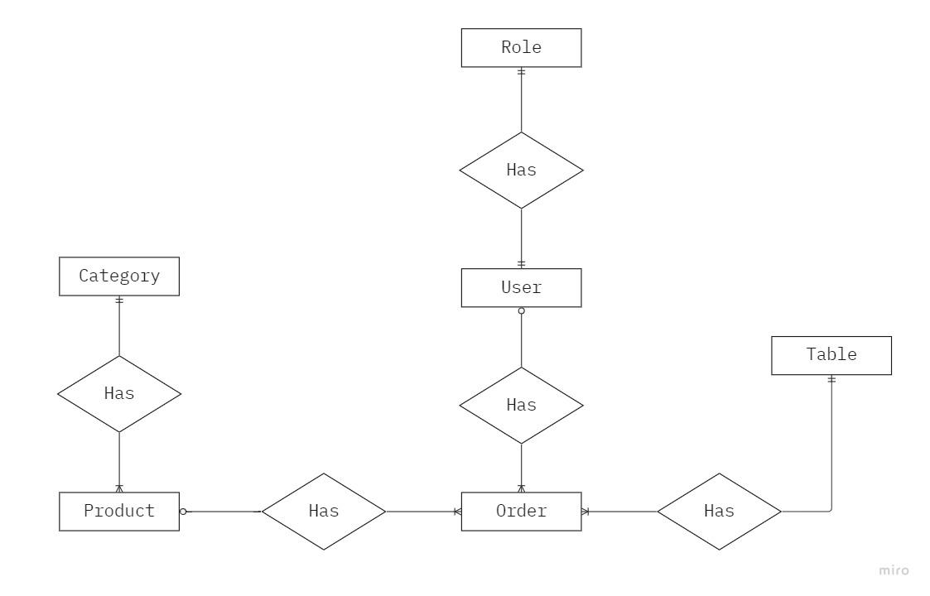

* + 1. **Database specification**
* **Users table:**

| **Properties** | **Datatypes** | **Width** | **lock up** |
| --- | --- | --- | --- |
| ID | Int |  | Primary Key |
| UserName | Varchar | 50 |  |
| Password | Varchar | 45 |  |
| Fullname | Varchar | 50 |  |
| Dob | Date |  |  |
| Email | Varchar | 250 |  |
| Phone | Varchar | 45 |  |
| Avatar_id | Int |  | Foreign Key |
| total_contribute | Float |  |  |
| Created_at | Datetime |  |  |
| Updated_at | Datetime |  |  |
| Created_by | Int |  |  |
| Updated_by | Int |  |  |
| Status | Bit | first |  |

* **Role Table:**

| **Properties** | **Datatypes** | **Width** | **lock up** |
| --- | --- | --- | --- |
| ID | Int |  | Primary Key |
| Name | Varchar | 50 |  |
| Status | Bit | first |  |

* **User_Role table:**

| **Properties** | **Datatypes** | **Width** | **lock up** |
| --- | --- | --- | --- |
| ID | Int |  | Primary Key |
| User_id | int |  | Foreign Key |
| Role_id | Int |  | Foreign Key |

* **Avatar table:**

| **Properties** | **Datatypes** | **Width** | **lock up** |
| --- | --- | --- | --- |
| ID | Int |  | Primary Key |
| Link | Varchar | 250 |  |
| Created_at | Datetime |  |  |
| Updated_at | Datetime |  |  |
| Created_by | Int |  |  |
| Updated_by | Int |  |  |
| Status | Bit |  |  |
| AvatarCol | Varchar | 45 |  |

* **Product Table:**

| **Properties** | **Datatypes** | **Width** | **lock up** |
| --- | --- | --- | --- |
| ID | Int |  | Primary Key |
| Name | Varchar | 50 |  |
| Category_id | Int |  | Foreign Key |
| Unit_id | Int |  | Foreign Key |
| Price | Float |  |  |
| Quantity | Int |  |  |
| Created_at | Datetime |  |  |
| Updated_at | Datetime |  |  |
| Created_by | Int |  |  |
| Updated_by | Int |  |  |
| Status | Bit |  |  |

* **Table Image:**

| **Properties** | **Datatypes** | **Width** | **lock up** |
| --- | --- | --- | --- |
| ID | Int |  | Primary Key |
| product_id | Int |  | Foreign Key |
| Link | Varchar | 50 |  |
| Created_at | Datetime |  |  |
| Updated_at | Datetime |  |  |
| Created_by | Int |  |  |
| Updated_by | Int |  |  |
| Status | Bit |  |  |

* **Table Category:**

| **Properties** | **Datatypes** | **Width** | **lock up** |
| --- | --- | --- | --- |
| ID | Int |  | Primary Key |
| Name | Varchar | 50 |  |
| Created_at | Datetime |  |  |
| Updated_at | Datetime |  |  |
| Created_by | Int |  |  |
| Updated_by | Int |  |  |
| Status | Bit |  |  |

* **Unit Table:**

| **Properties** | **Datatypes** | **Width** | **lock up** |
| --- | --- | --- | --- |
| ID | Int |  | Primary Key |
| Name | Varchar | 50 |  |
| Created_at | Datetime |  |  |
| Updated_at | Datetime |  |  |
| Created_by | Int |  |  |
| Updated_by | Int |  |  |
| Status | Bit |  |  |

* **Order Table:**

| **Properties** | **Datatypes** | **Width** | **lock up** |
| --- | --- | --- | --- |
| ID | Int |  | Primary Key |
| User_id | Int |  | Foreign Key |
| product_id | Int |  | Foreign Key |
| Quantity | Int |  |  |
| Total_price | Float |  |  |
| Table_id | Int |  | Foreign Key |
| Payment_now | Bit | first |  |
| Note | Varchar | 250 |  |
| Created_by | Int |  |  |
| Updated_by | Int |  |  |
| Status | Bit |  |  |

* **Table Table:**

| **Properties** | **Datatypes** | **Width** | **lock up** |
| --- | --- | --- | --- |
| ID | Int |  | Primary Key |
| Name | Varchar | 45 |  |
| Table_status | Int |  |  |
| Status | Bit | first |  |

* + 1. **Database Diagram**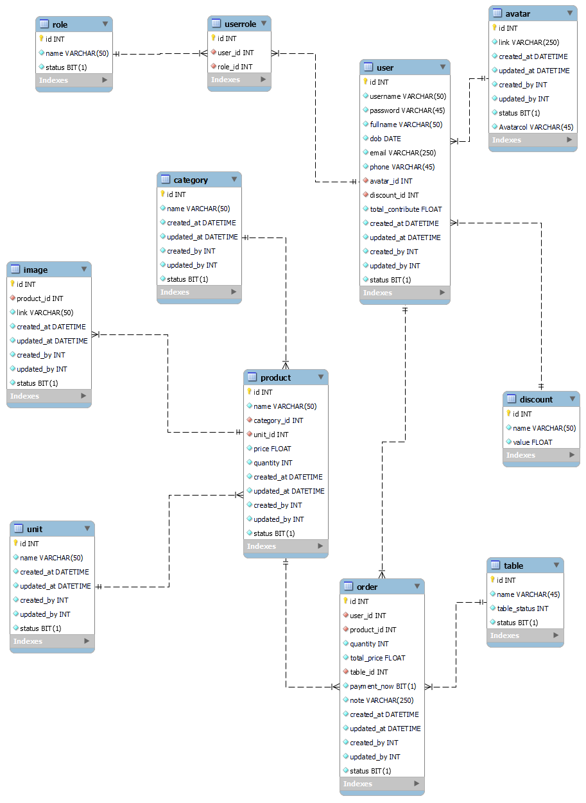
    2. **Site map**
* **Employee :**

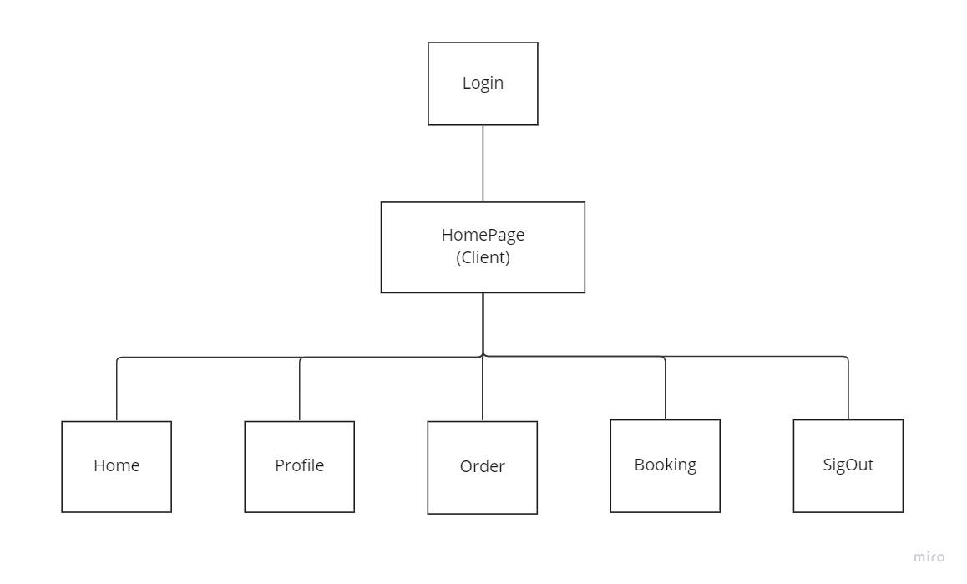

* **Admin:**

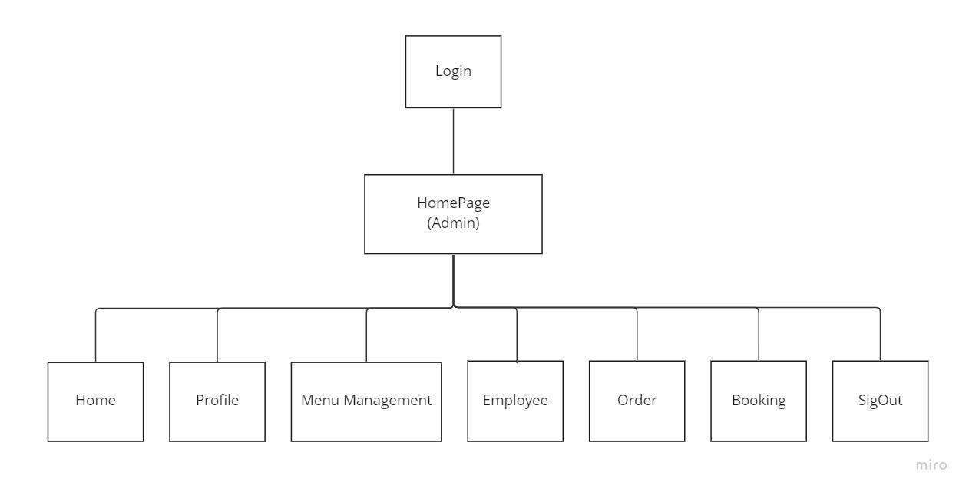

* + 1. **Some algorithms applied in the project**
* **Login**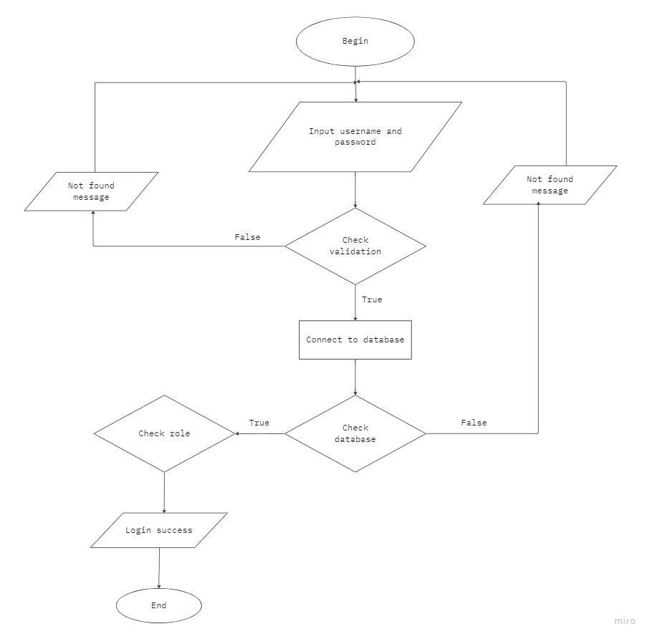
* **Search:**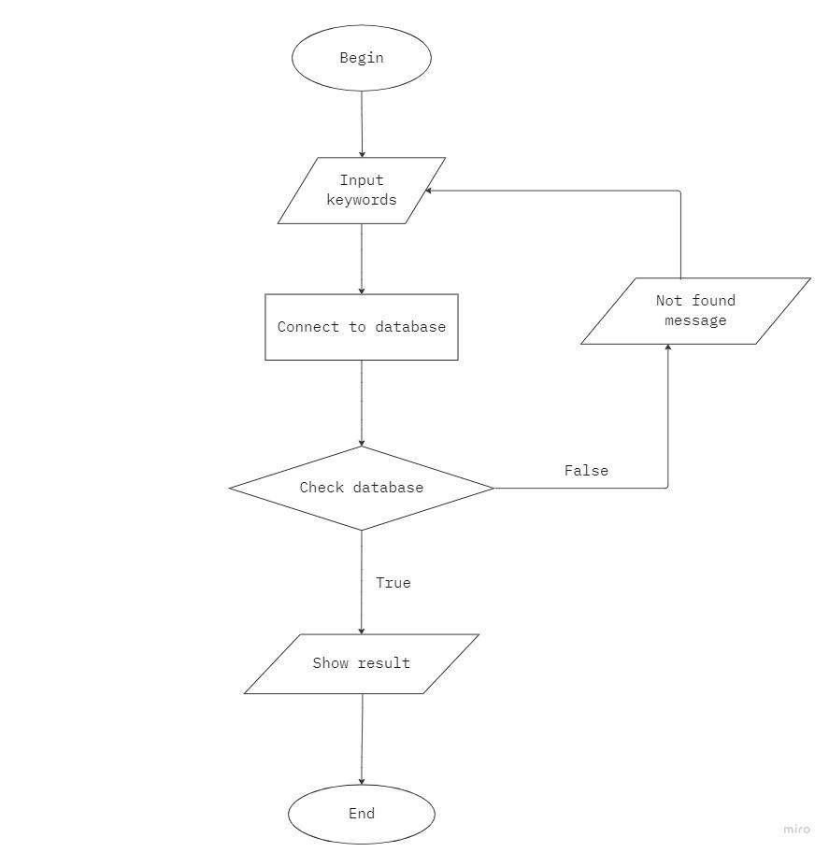
  1. **Some illustrations**
* **Login:**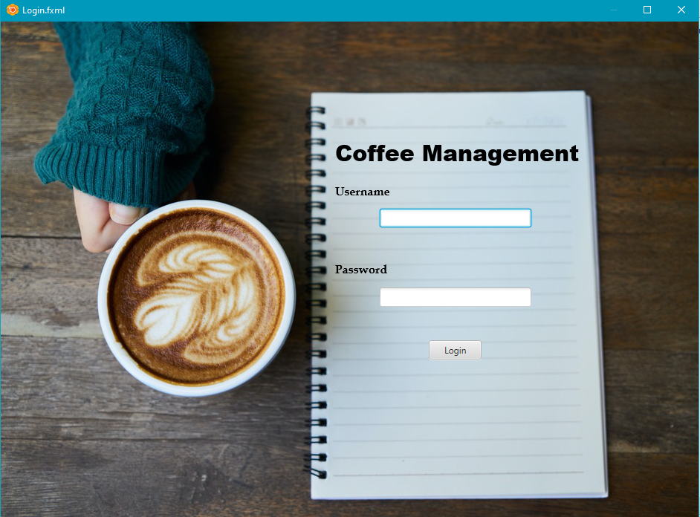
* **HomePageAdmin:**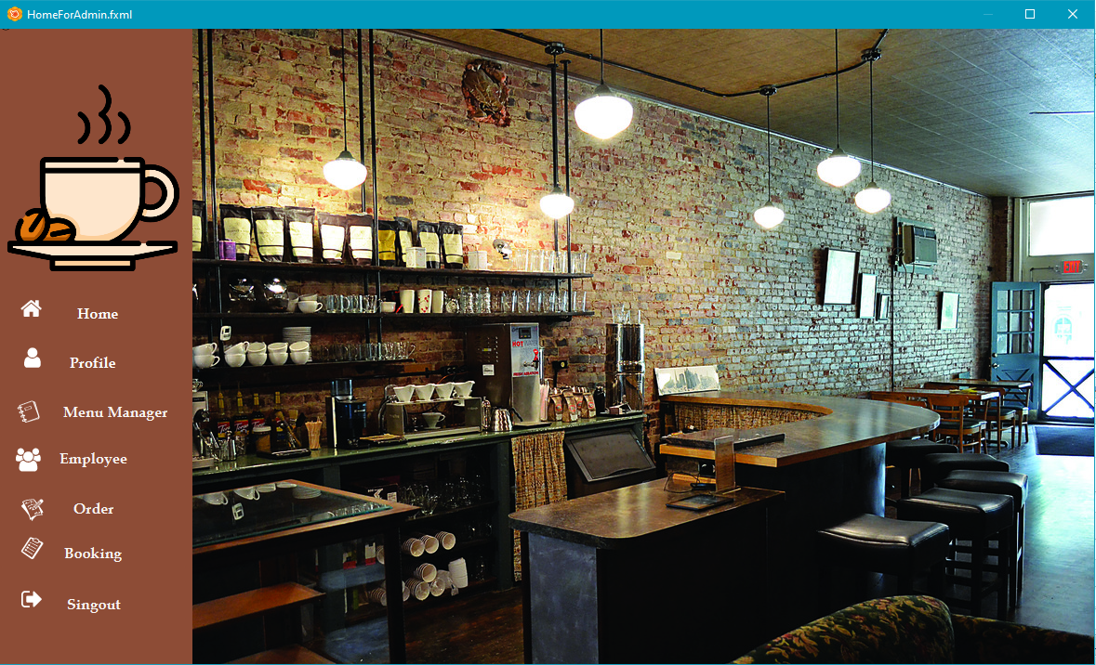
* **HomePageEmployee:**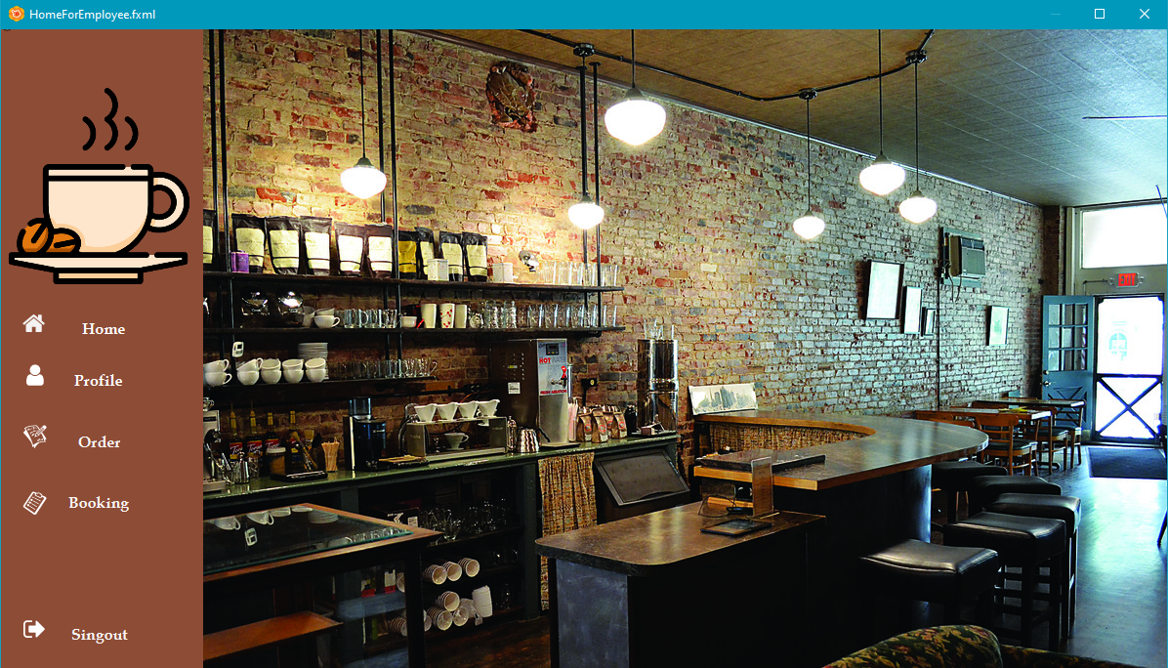
* **Management menu:**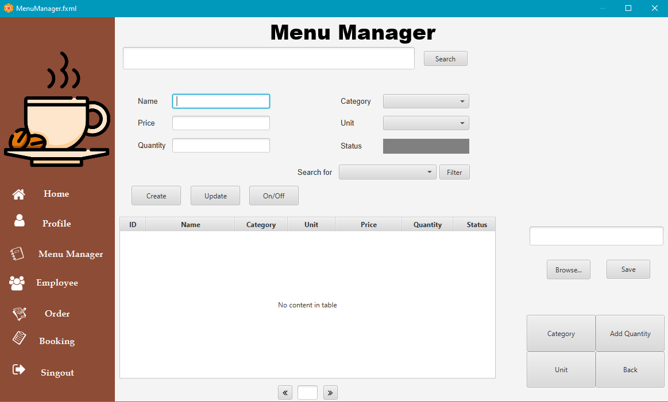
* **Admin Profile:**

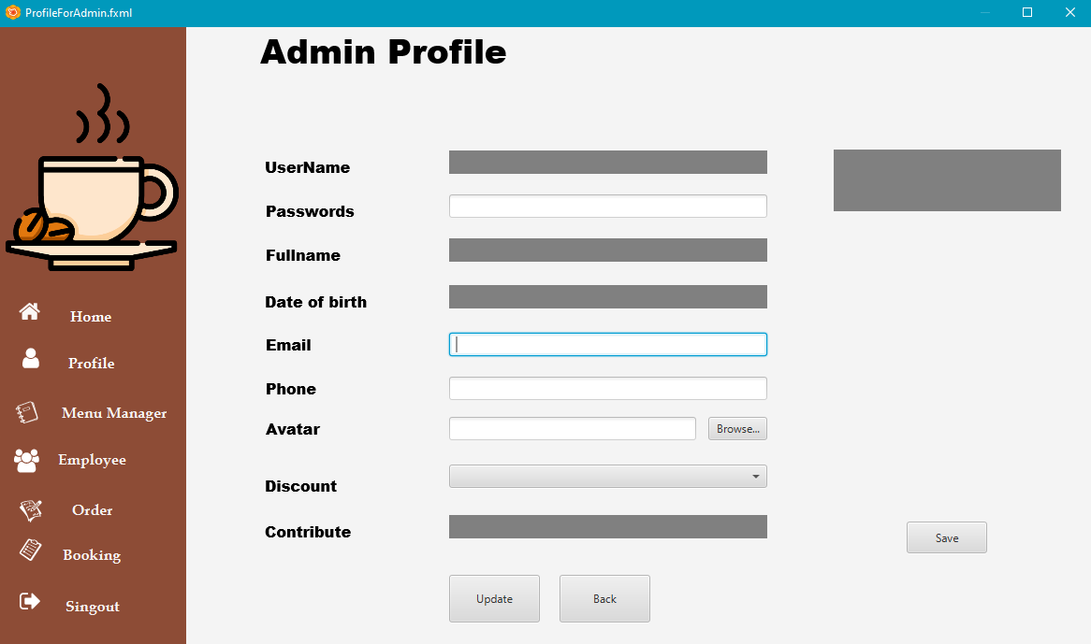

* **Employee Profile:**

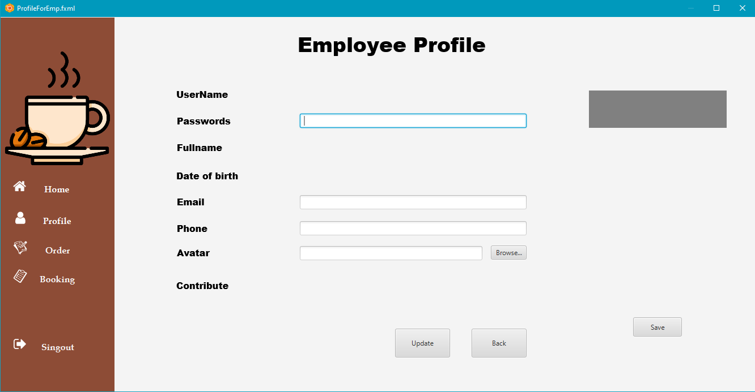

* 1. **Tasksheet**

| **Task** | **Start time** | **Finish time** | **Implemented by** | **Evaluation(%)** |
| --- | --- | --- | --- | --- |
| Research phase of the topic |  |  |  |  |
| Write documentation | 09/11/2022 | 13/11/2022 | Ngo Minh Chien | 20 |
| Comments and suggestions | 11/11/2022 | 13/11/2022 | Truong Anh Long | 25 |
| Le Thi Anh Lan | 25 |
| Comments and suggestions | 11/11/2022 | 13/11/2022 | Le Dang Truong Phat | 15 |
| Cao Duy Quang | 15 |
| Requirements analysis stage |  |  |  |  |
| Write documentation | 14/11/2022 | 18/11/2022 | Ngo Minh Chien | 30 |
| Comments and suggestions | 16/11/2022 | 18/11/2022 | Truong Anh Long | 30 |
| Comments and suggestions | 16/11/2022 | 18/11/2022 | Le Thi Anh Lan | 30 |
| Comments and suggestions | 16/11/2022 | 18/11/2022 | Cao Duy Quang | 5 |
| Le Dang Truong Phat | 5 |
| Stage design |  |  |  |  |
| Write documentation | 19/11/2022 | 23/11/2022 | Ngo Minh Chien | 30 |
| Comments and suggestions | 21/11/2022 | 23/11/2022 | Le Thi Anh Lan | 25 |
| Comments and suggestions | 21/11/2022 | 23/11/2022 | Truong Anh Long | 35 |
| Browse and edit | 21/11/2022 | 23/11/2022 | Ngo Minh Chien | 10 |
| Development stage |  |  |  |  |
| Write documentation | 24/11/2022 | 26/11/2022 | Ngo Minh Chien | 20 |
| Write code | 26/11/2022 | 08/12/2022 | Truong Anh Long | 40 |
| Write code | 26/11/2022 | 08/12/2022 | Le Thi Anh Lan | 30 |
| Comments and suggestions | 26/11/2022 | 08/12/2022 | Cao Duy Quang | 5 |
| Comments and suggestions | 26/11/2022 | 08/12/2022 | Le Dang Truong Phat | 5 |
| Testing phase |  |  |  |  |
| Test and comments | 05/12/2022 | 08/12/2022 | Truong Anh Long | 35 |
| 05/12/2022 | 08/12/2022 | Le Thi Anh Lan | 35 |
| 05/12/2022 | 08/12/2022 | Ngo Minh Chien | 20 |
| Comments and suggestions | 05/12/2022 | 08/12/2022 | Le Dang Truong Phat | 5 |
| Cao Duy Quang | 5 |

* 1. **Validate cheklist**
* **Login:**
* UserName, Password required.
* Check UserName and Password in database.
* **Menu Manager:**
* Name, Price, Quantity, Category, Unit required.
* **Admin Profile:**
* UserName, Password, FullName, Date of Birth, Email, Phone required.
* **Employee Profile:**
* UserName, Password, FullName, Date of Birth, Email, Phone required.

# **Chapter 3. Conclusion and development direction**

* + 1. **Conclusion**
* **Advantages:**
* Learn about Java language, JavaFX.
* Know more about SceneBuilder, NetBeans IDE.
* Improved problem analysis ability.
* **Defect:**
* The system has many shortcomings.
* The interface is not beautiful, some skills are still weak.
  1. **Development**
* The system will develop more features in the future according to user needs.
* The system strives to develop and improve on a more beautiful and unique interface